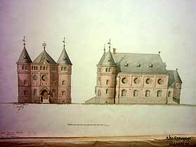
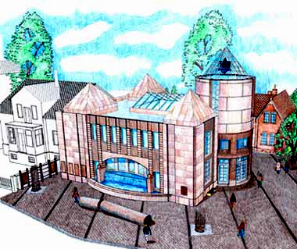
< old synagogue
Hameln

Planned new synagogue
Hameln >

BENEFIT CONCERT for the new

Hameln Synagogue

November 5, 2005

7:30 P.M. Weserberglandzentrum

SHALOM Songs in Hebrew, German
(Jewish Congregation of Hameln) and Russian

REBEKKA DOHME Liturgy and modern
(Jewish Congregation Hameln) songs in Hebrew

ALINA TREIGER Liturgy in Hebrew
(Abraham Geiger College) Yiddish songs
Jewish songs in Russian
DUO CHALIL Klezmer
JABBOQ Klezmer
KATARINA KRÄMER Jewish melodies
WILHELM GROTE Guitar
Yiddish tunes

Tickets: DEWEZET, Radio Aktiv, Jewish Congregation Hameln,

Bahnhofstraße 22, 31785 Hameln
Price: 12,00 Euros

